Name**:- Ankit Jaiswar**

Roll no:- **40.**

Subject:- **Business intelligence and big data.**

Topic:- **MongoDB.**

**Aim:** Installing MongoDB and Performing CRUD operations using cmd and MongoDB compass.

**Note:** 1. for performing a CRUD operation in MongoDB, we have to install MongoDB setup first.

https://[www.mongodb.com/try/download/community](http://www.mongodb.com/try/download/community)

2. We also need to install MongoDB compass following with MongoDB setup.

**Installation Instructions:** Set the Environment variable.

1. copy the path of the bin folder.

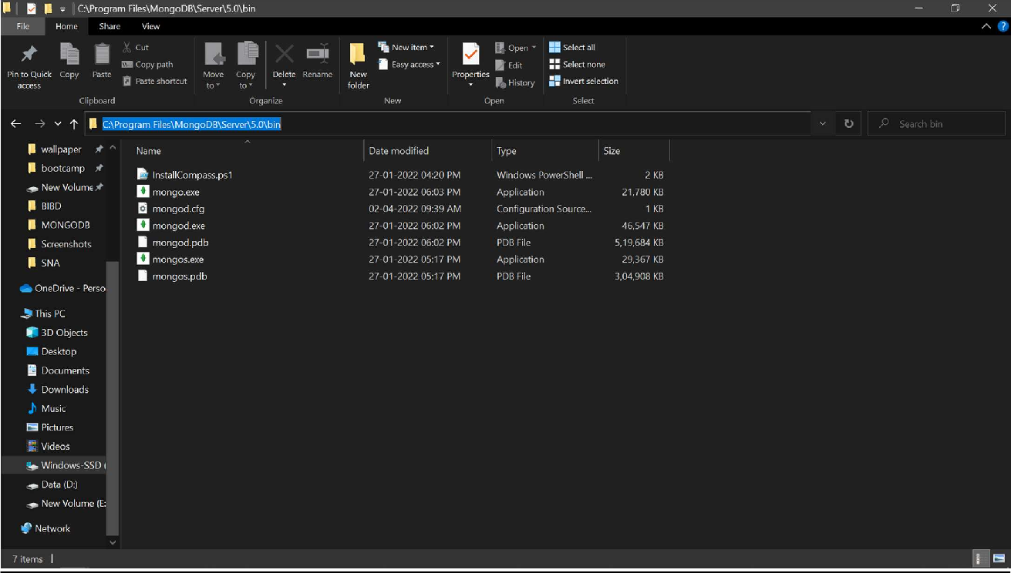

1. 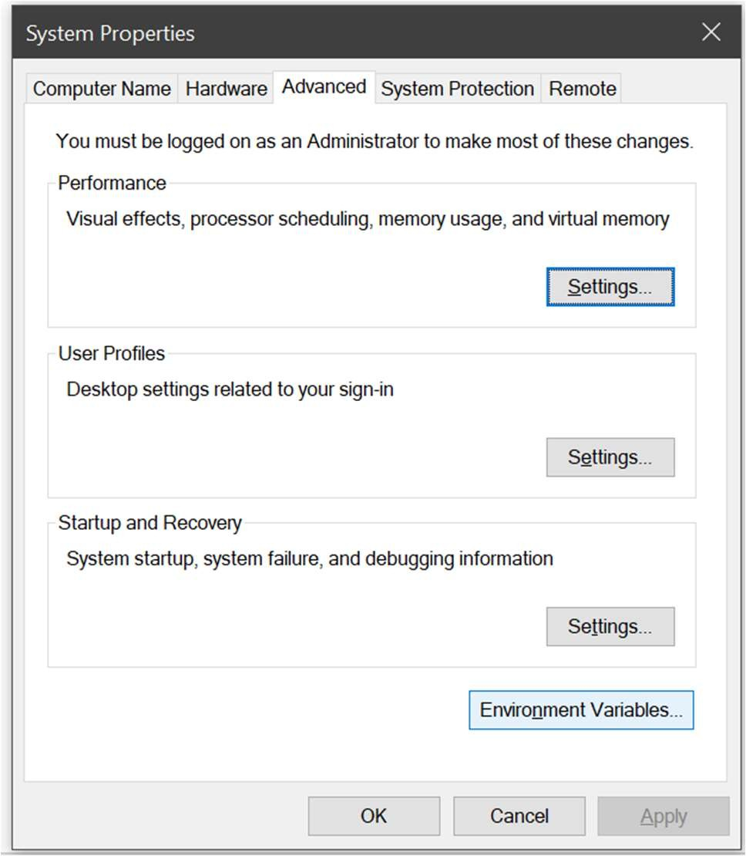open environment variable in the system.
2. click on path and press edit.
3. click on the new button which is present on the right side and paste the path link of the bin folder of MongoDB.

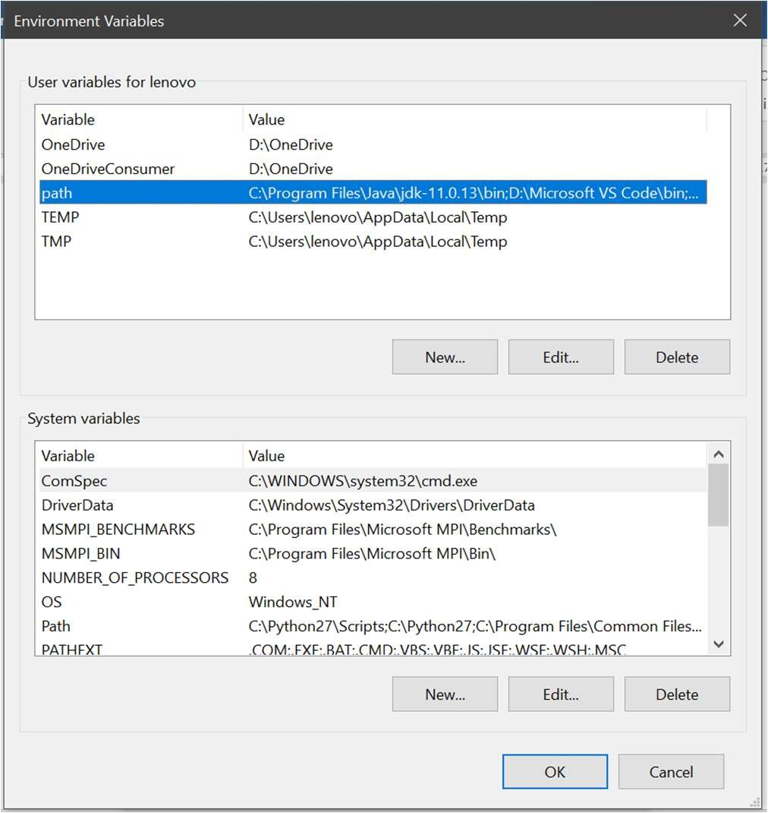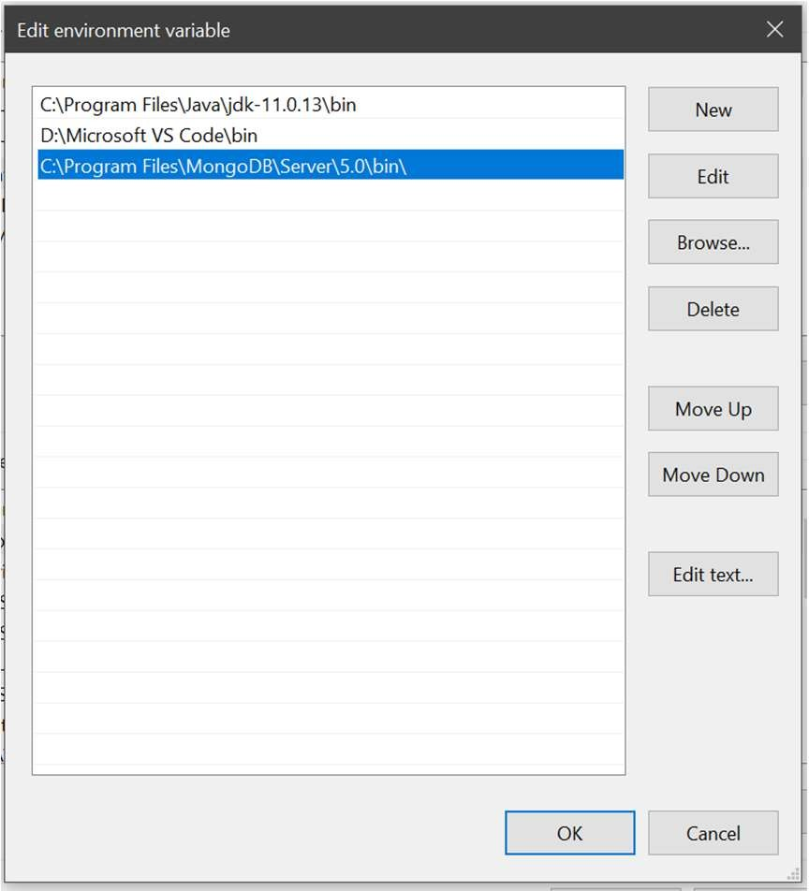

CRUD Operations Using CMD

**A.** Performing CRUD operation using cmd



There is some naming convention in MongoDB that is different from SQL or RDBMS.

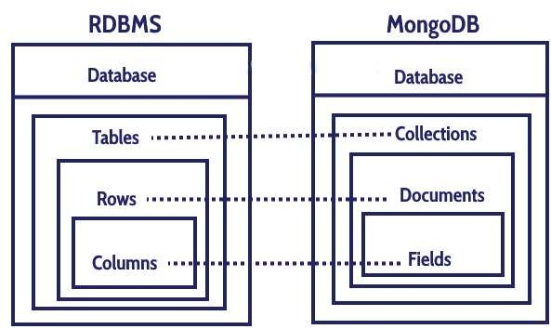

1. By using the command mongo we start MongoDB in cmd.

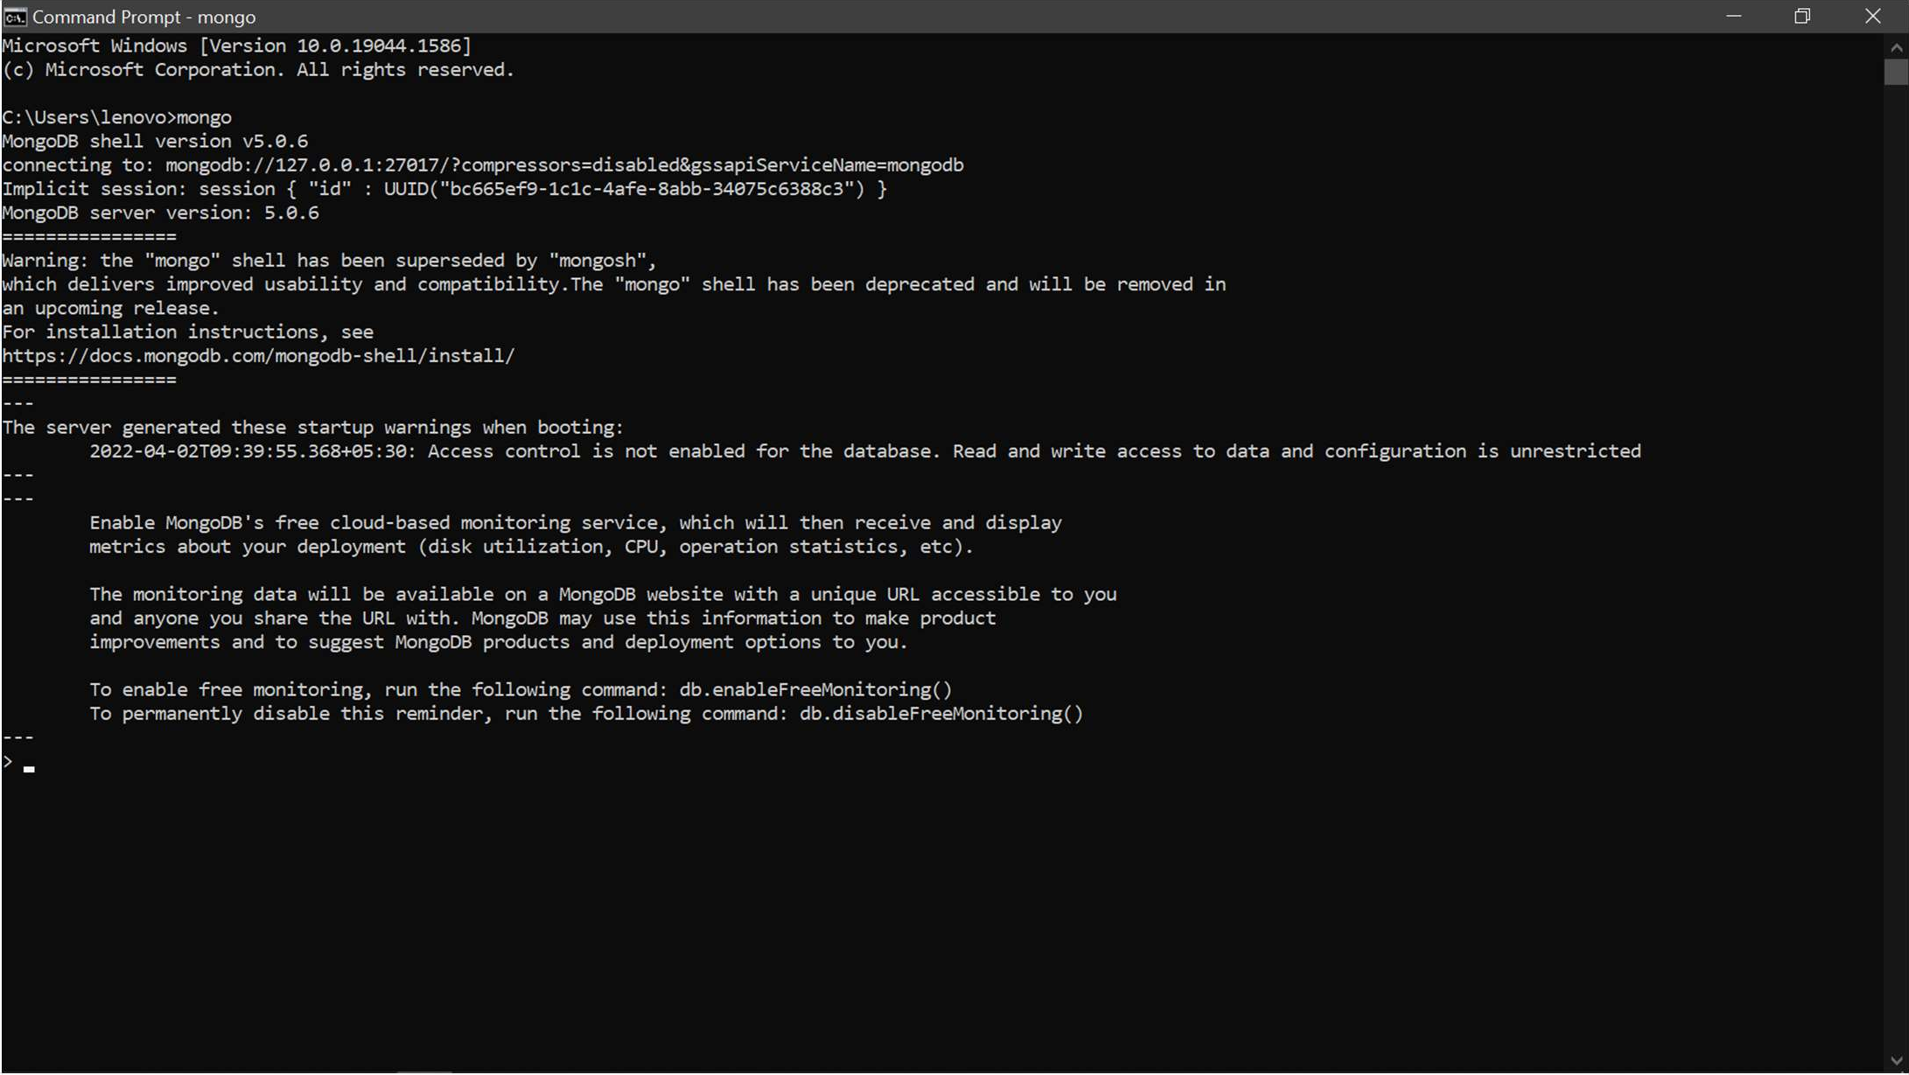

1. 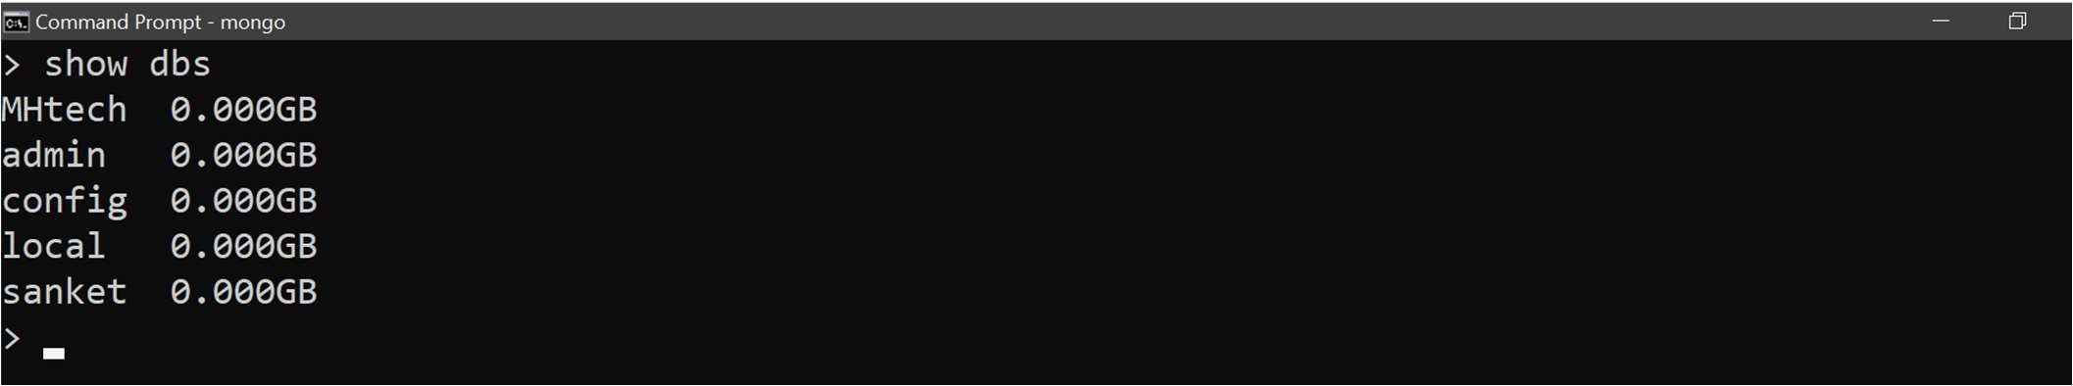By using the “show dbs” command we can see present databases.
2. Now we are using the “use ” command so the new database will be created and by using the “db” command we can see the current database on which we are working.

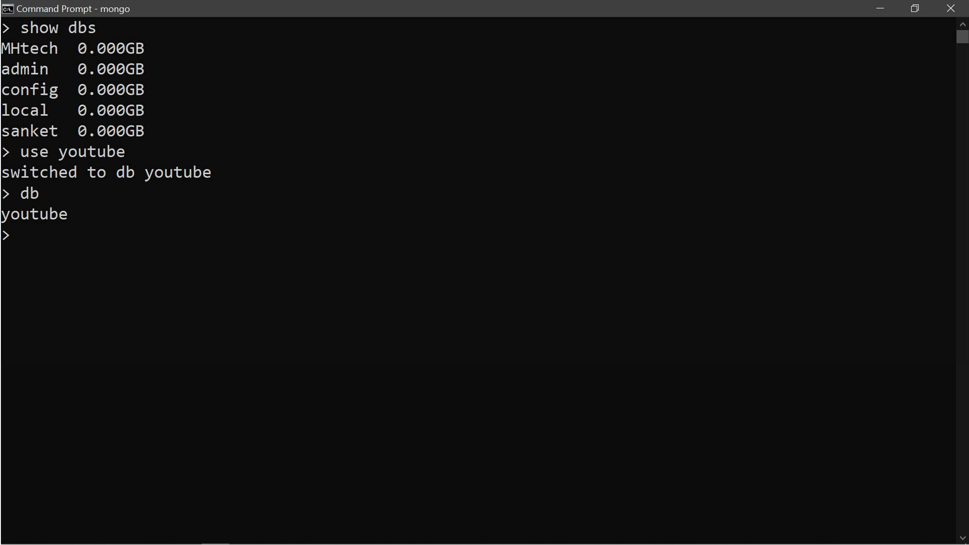

1. Now we are going to perform CRUD operations one by one inside it:-
   1. Create or Insert document:-

Commands for inserting and creating documents are “db.collection_name.insertOne” and “db.collection_name.insertMany” where insertOne is used for insert only one document and insertMany is used for inserting multiple documents. And gives a unique object id for every document.

* + 1. db.collection_name.insertOne:-

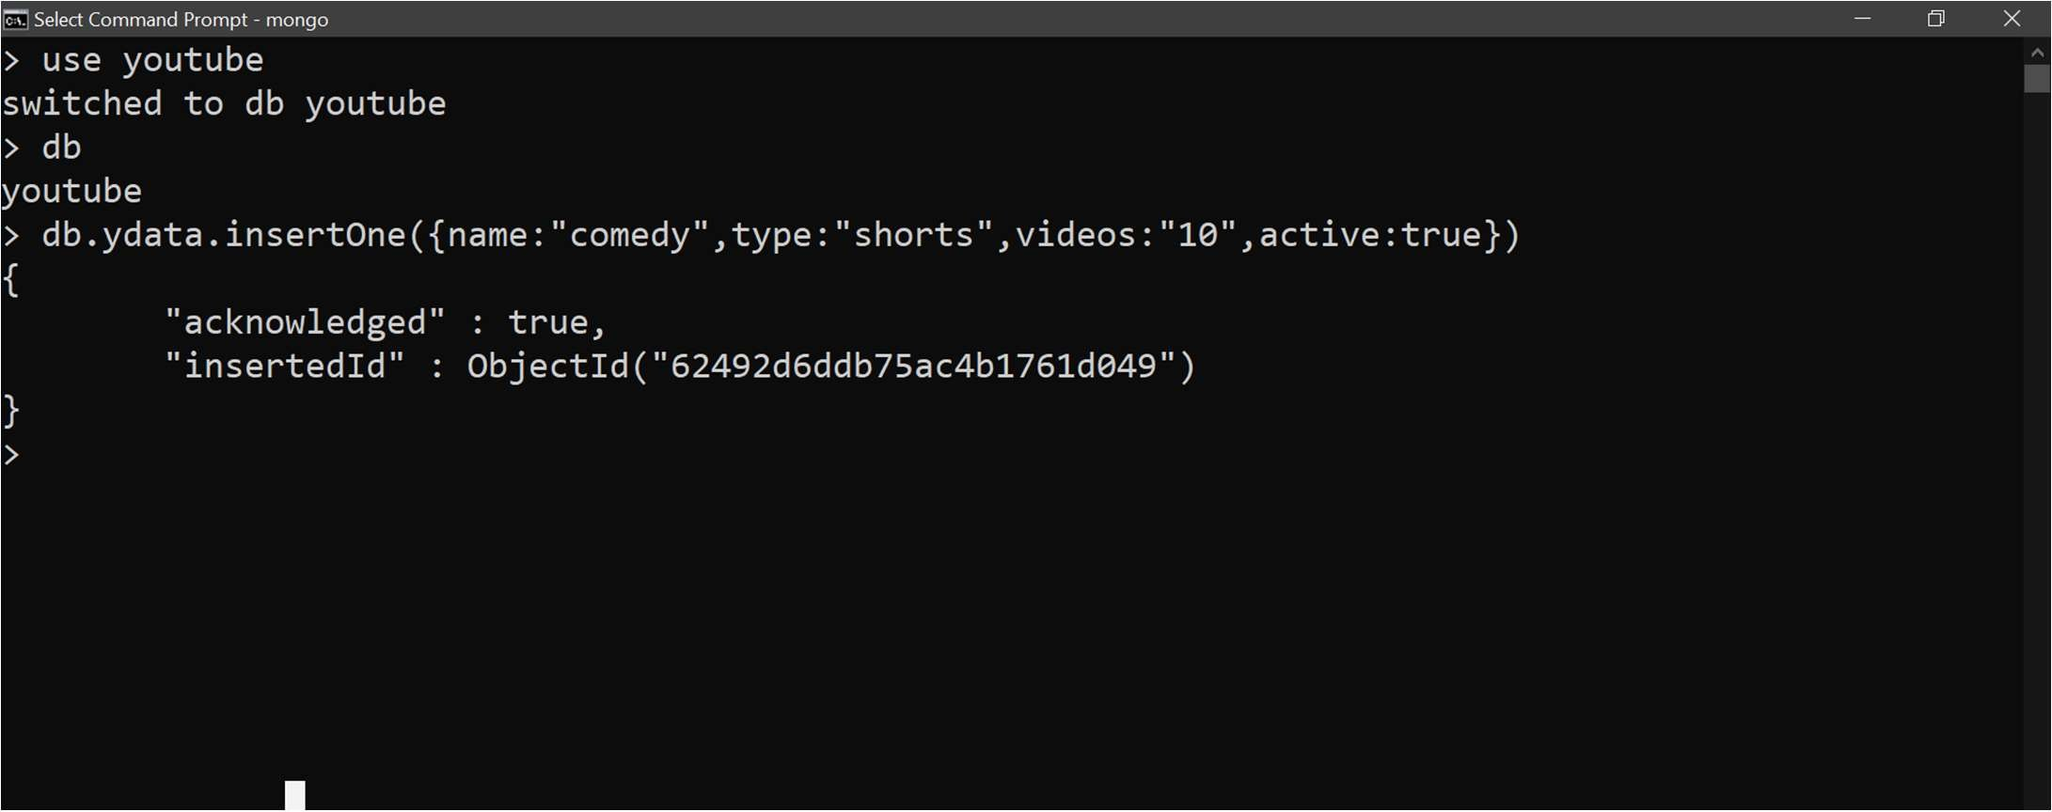

* + 1. db.collection_name.insertMany:-

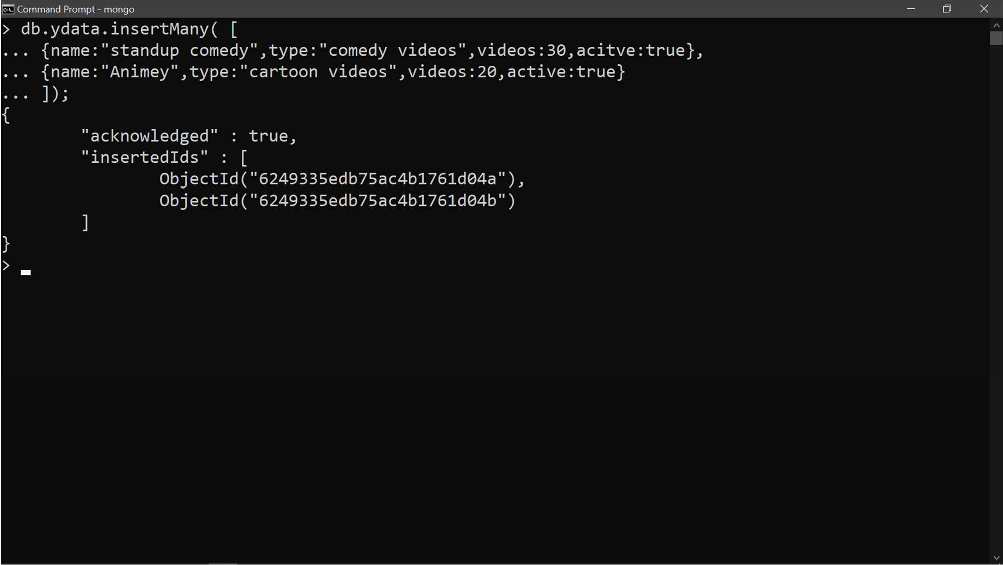

* 1. Read Documents:-

For reading a document there are following commands:-

1. db.collection_name.find()
2. db.collection_name.find({key :value})
3. db.collection_name.find().pretty()
4. db.collection_name.find().limit()

* db.collection_name.find():-

by using this command we can see documents but not in organized manner

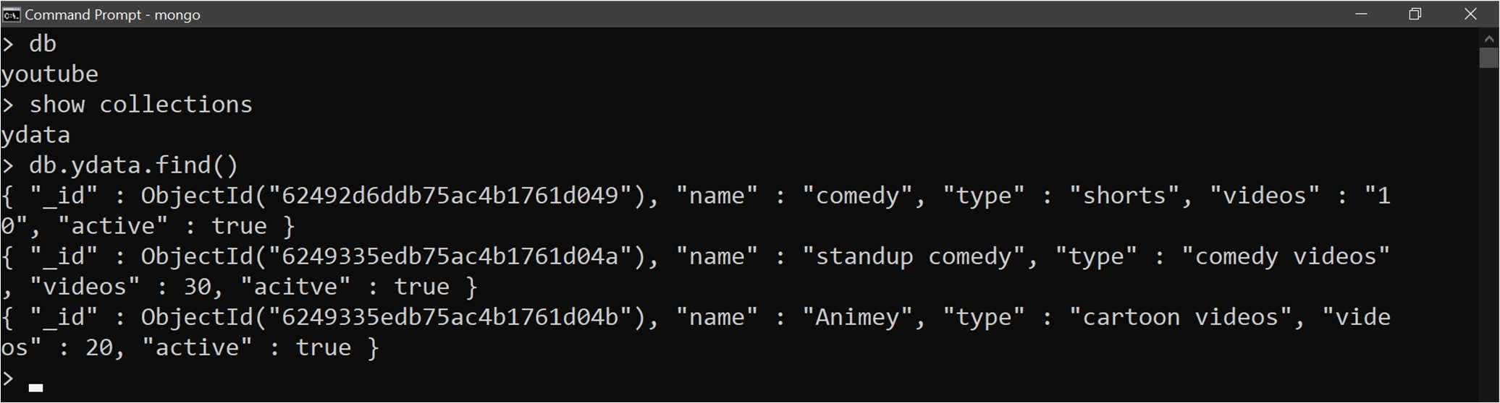

* db.collection_name.find({key :value})

Here is an example for searching a particular data



* db.collection_name.find().pretty():

by using this command we can see document in organized manner

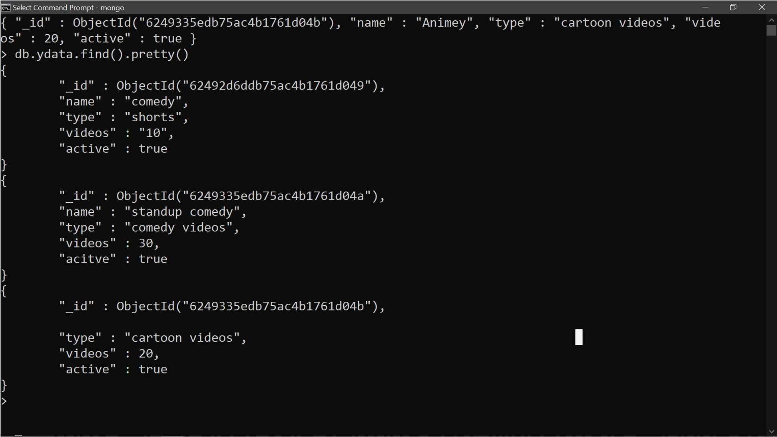

* 1. Update documents:-

For updating documents there are following commands :-

1. db.collection_name.updateOne({key:value} {$set:{key:value}})
2. db.collection_name.updateMany({key:value} {$set:{key:value}})

* db.collection_name.updateOne({key:value} {$set:{key:value}})

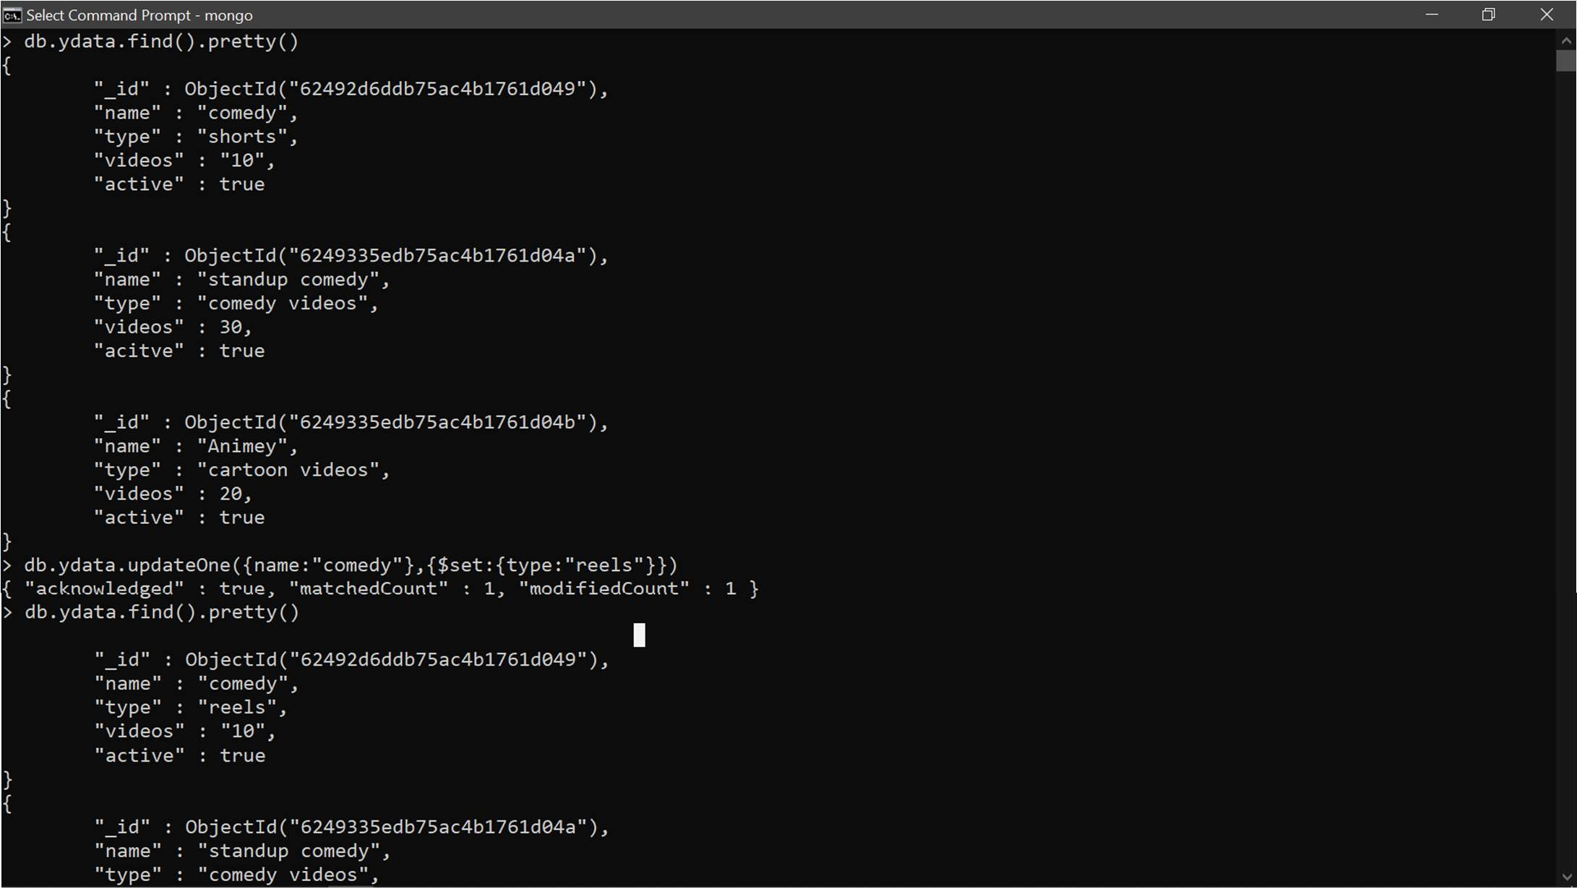

* db.collection_name.updateMany({key:value} {$set:{key:value}})

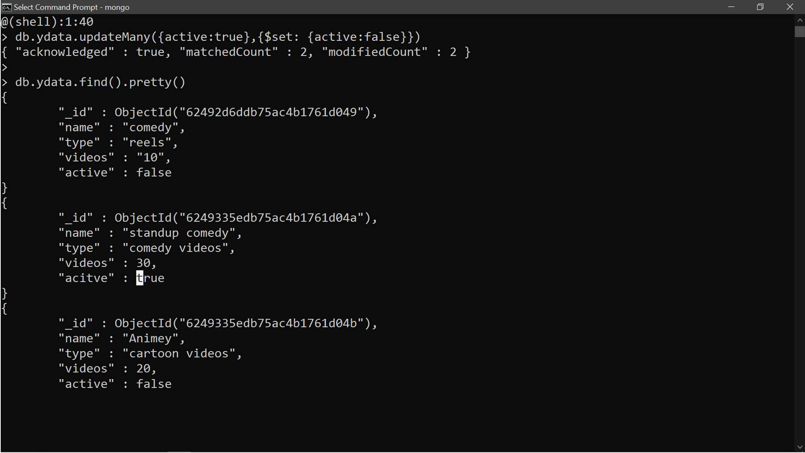

* 1. Delete the documents:-

We can delete documents from collections

* Db.collection_name.deleteMany({key:value})

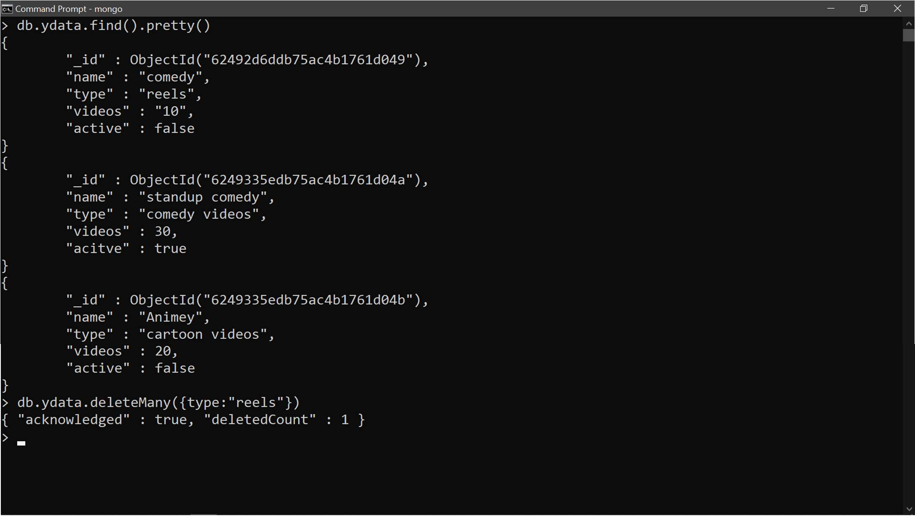

**B.** Performing CRUD operations using MongoDB compass

1. 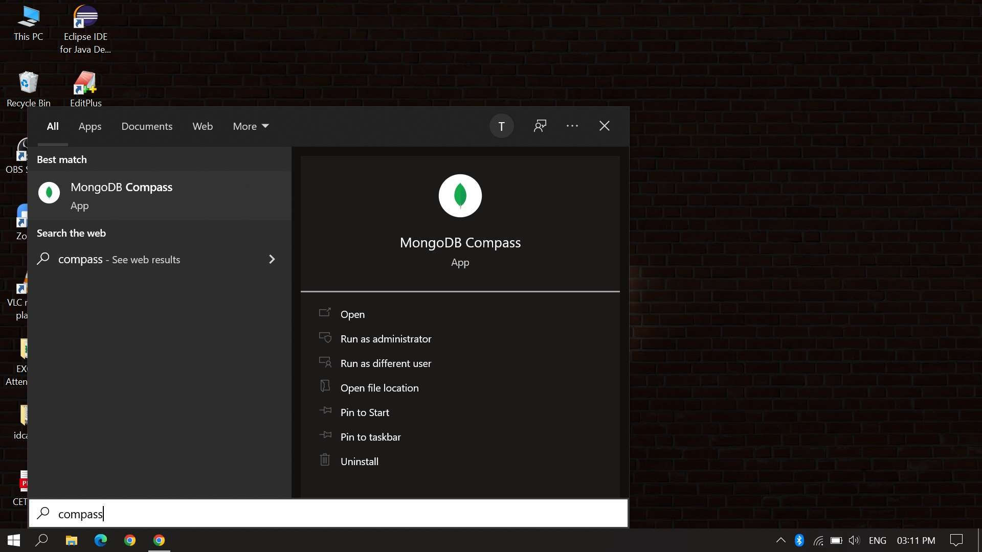First we have to open MongoDB compass in system.
2. 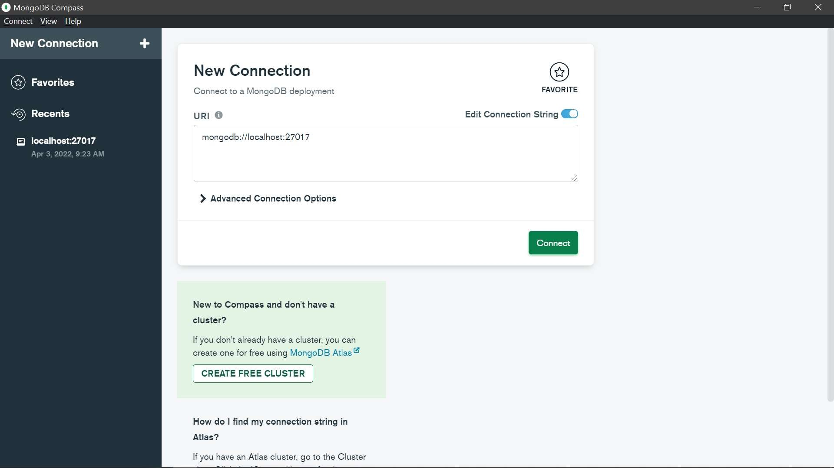The new window is open which is shown below
3. 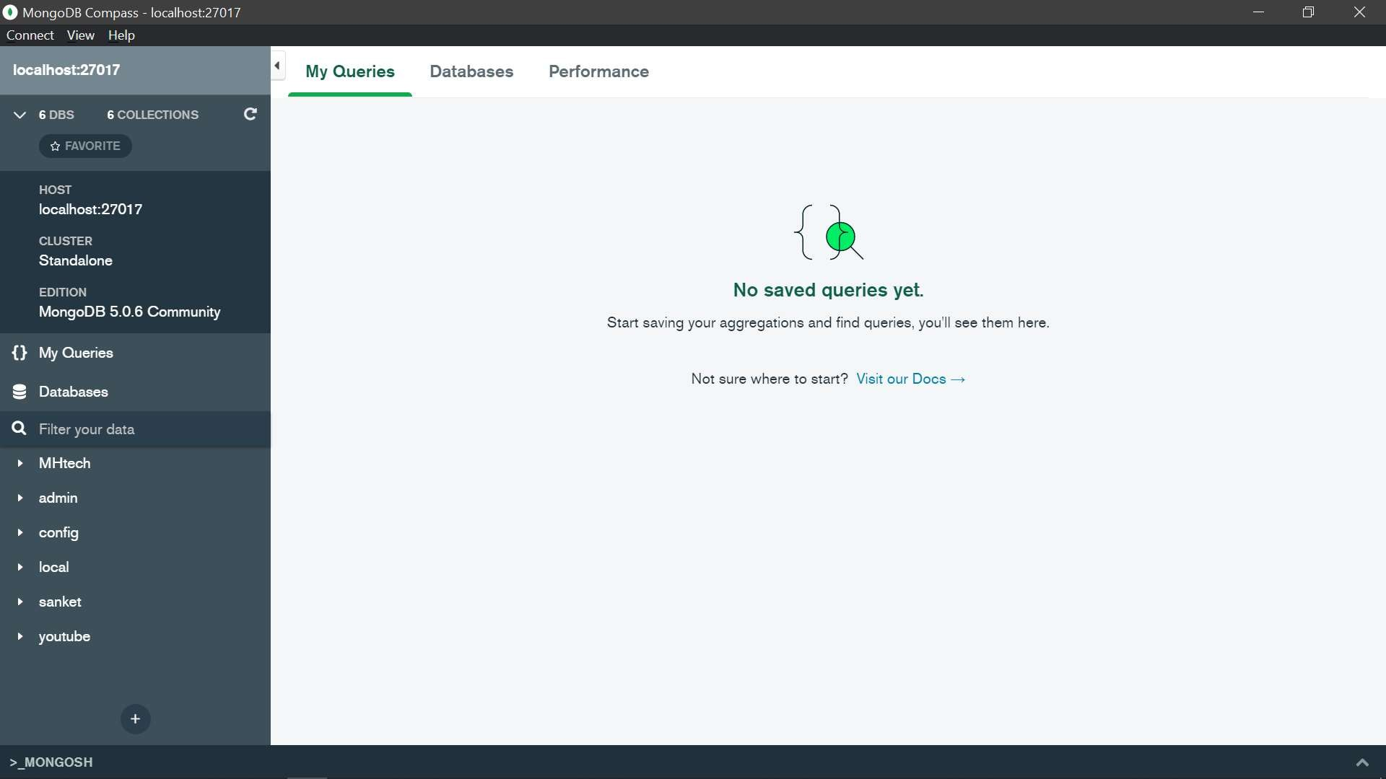After pressing connect we will redirect to the localhost page or database page.
4. On this page we will see our databases on the left side of page .
5. Now we will open any database and be able to update, insert, read and delete data very easily. Example:-

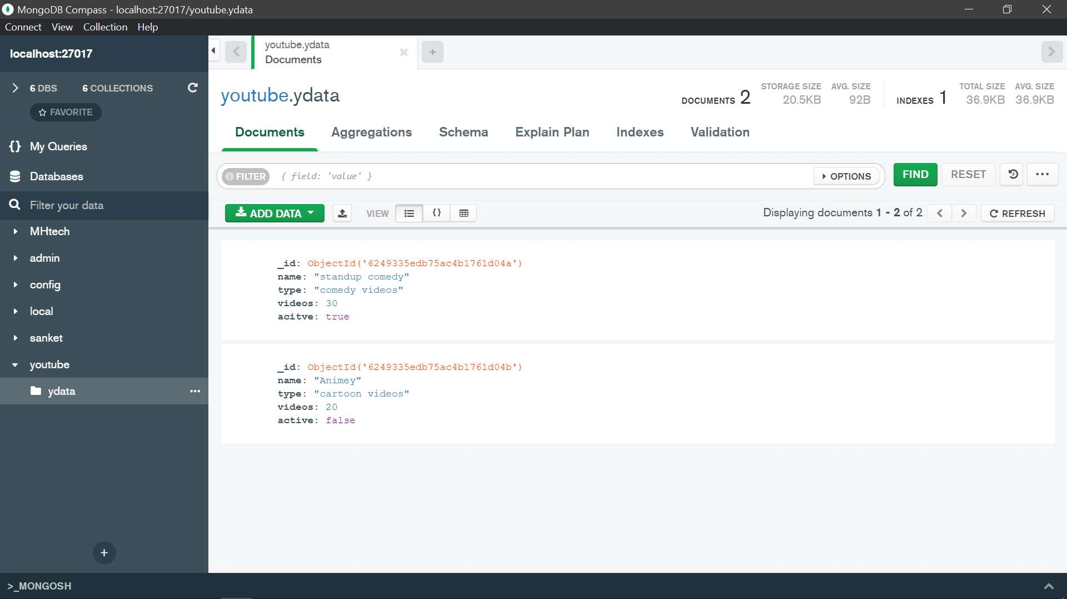We just created one database using cmd which is youtube

Now we are going to perform CRUD operations on it using MongoDB Compass.

CRUD Operations Using MongoDB compass

1. Create and insert a document in collections.
   1. First click on add data and then click insert document.

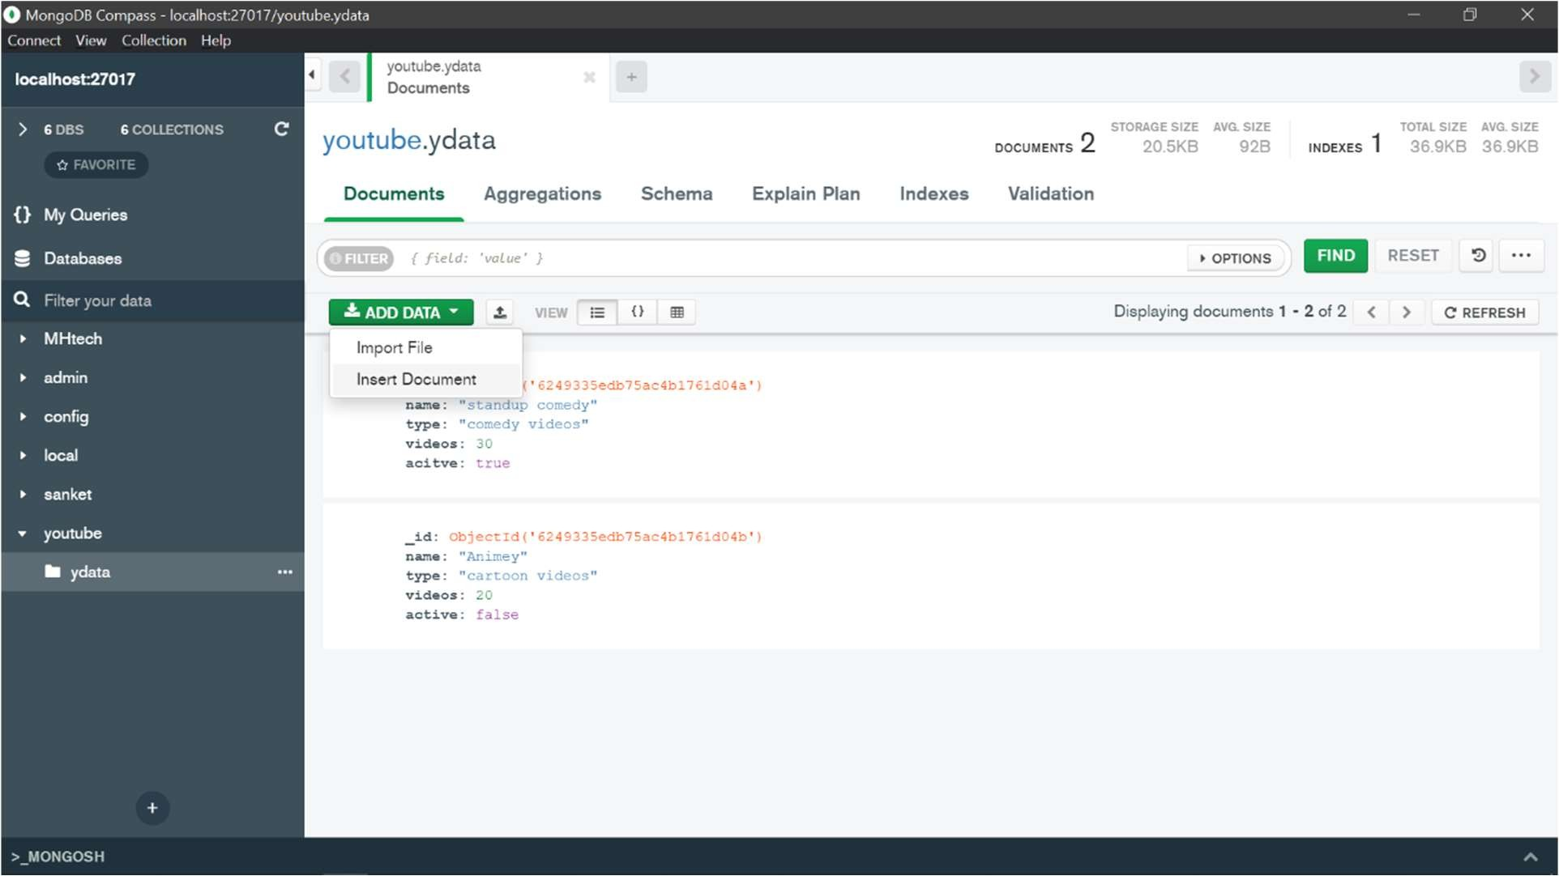

* 1. Then click on the button which is highlighted in picture

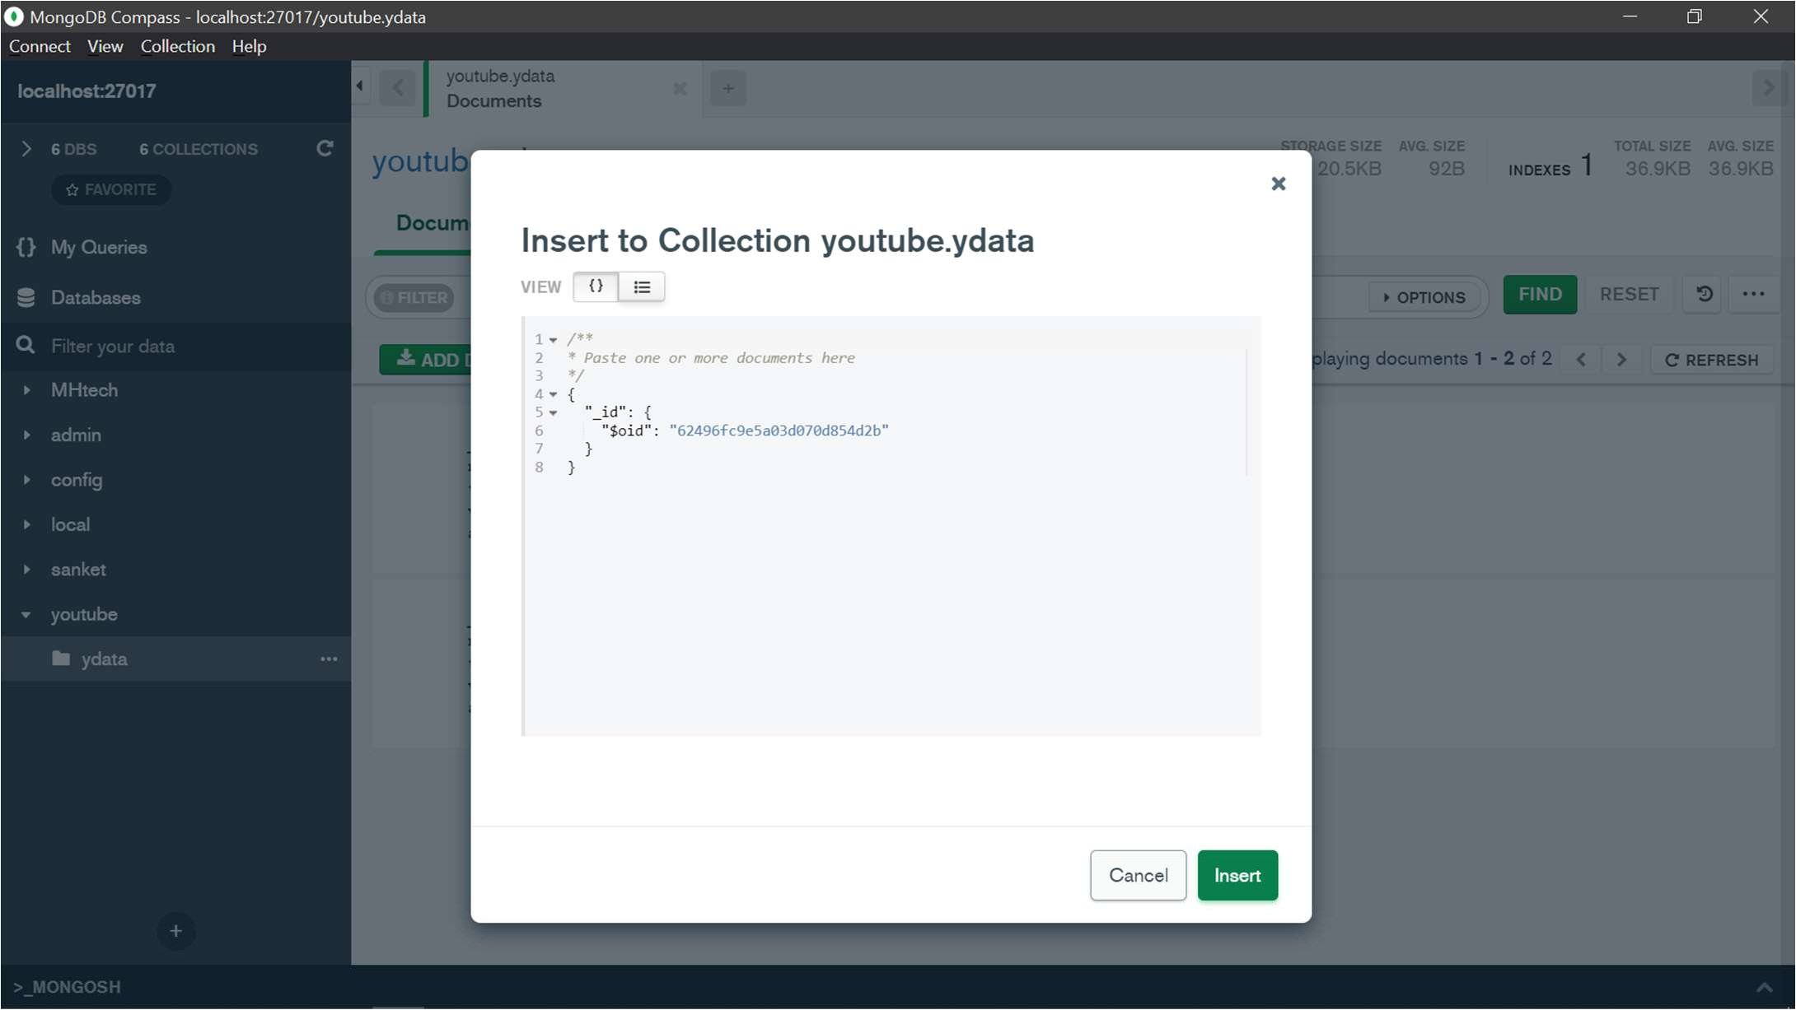

* 1. After inserting data press insert .

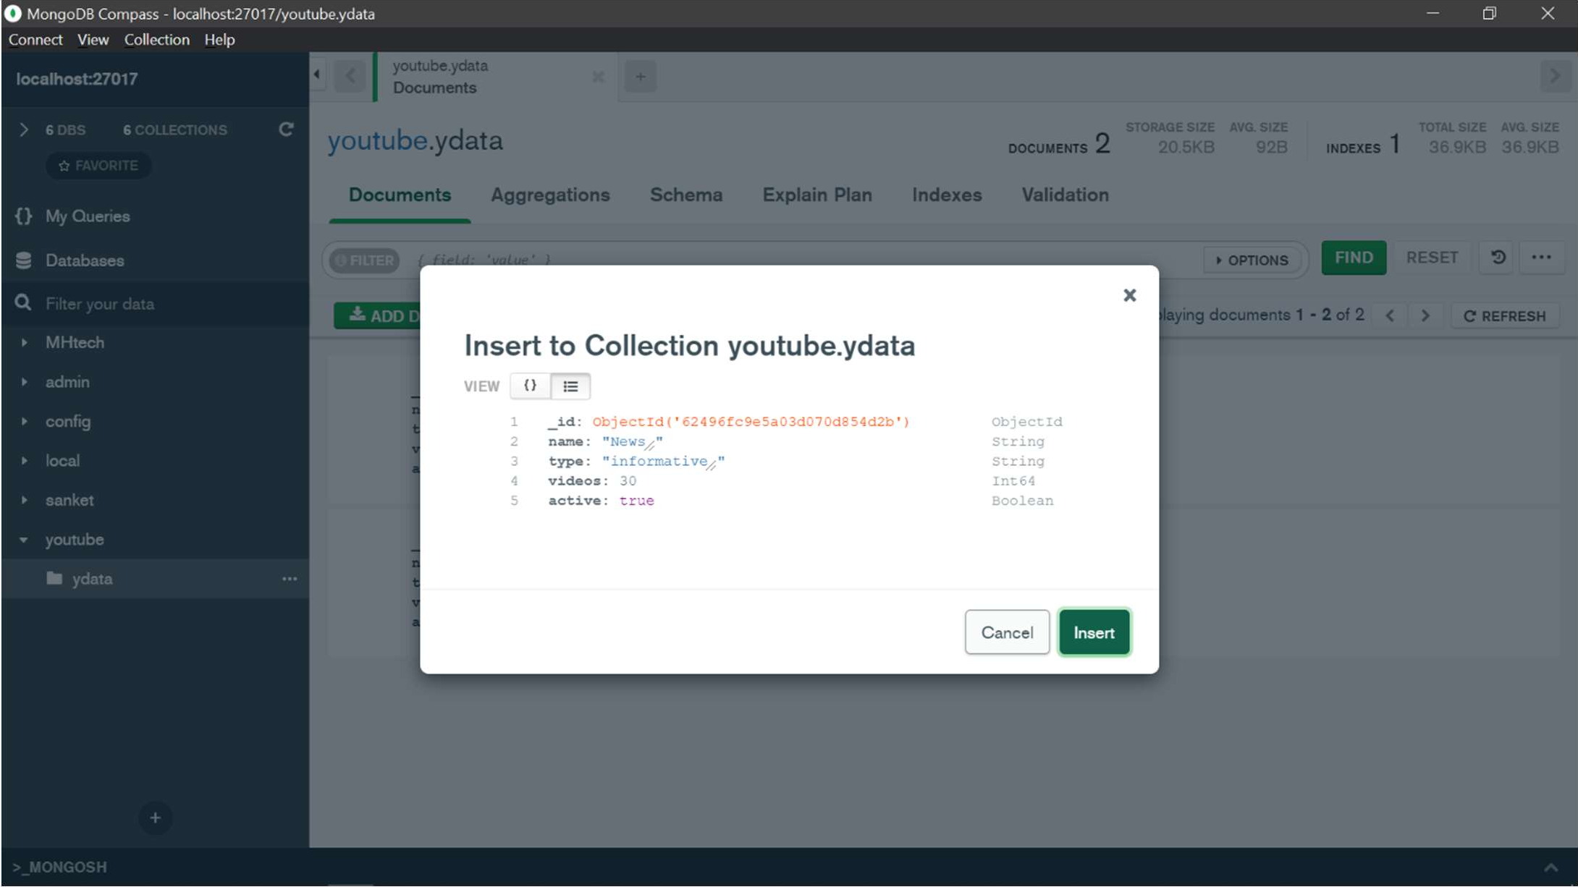

* 1. Now data or document is inserted in collection.

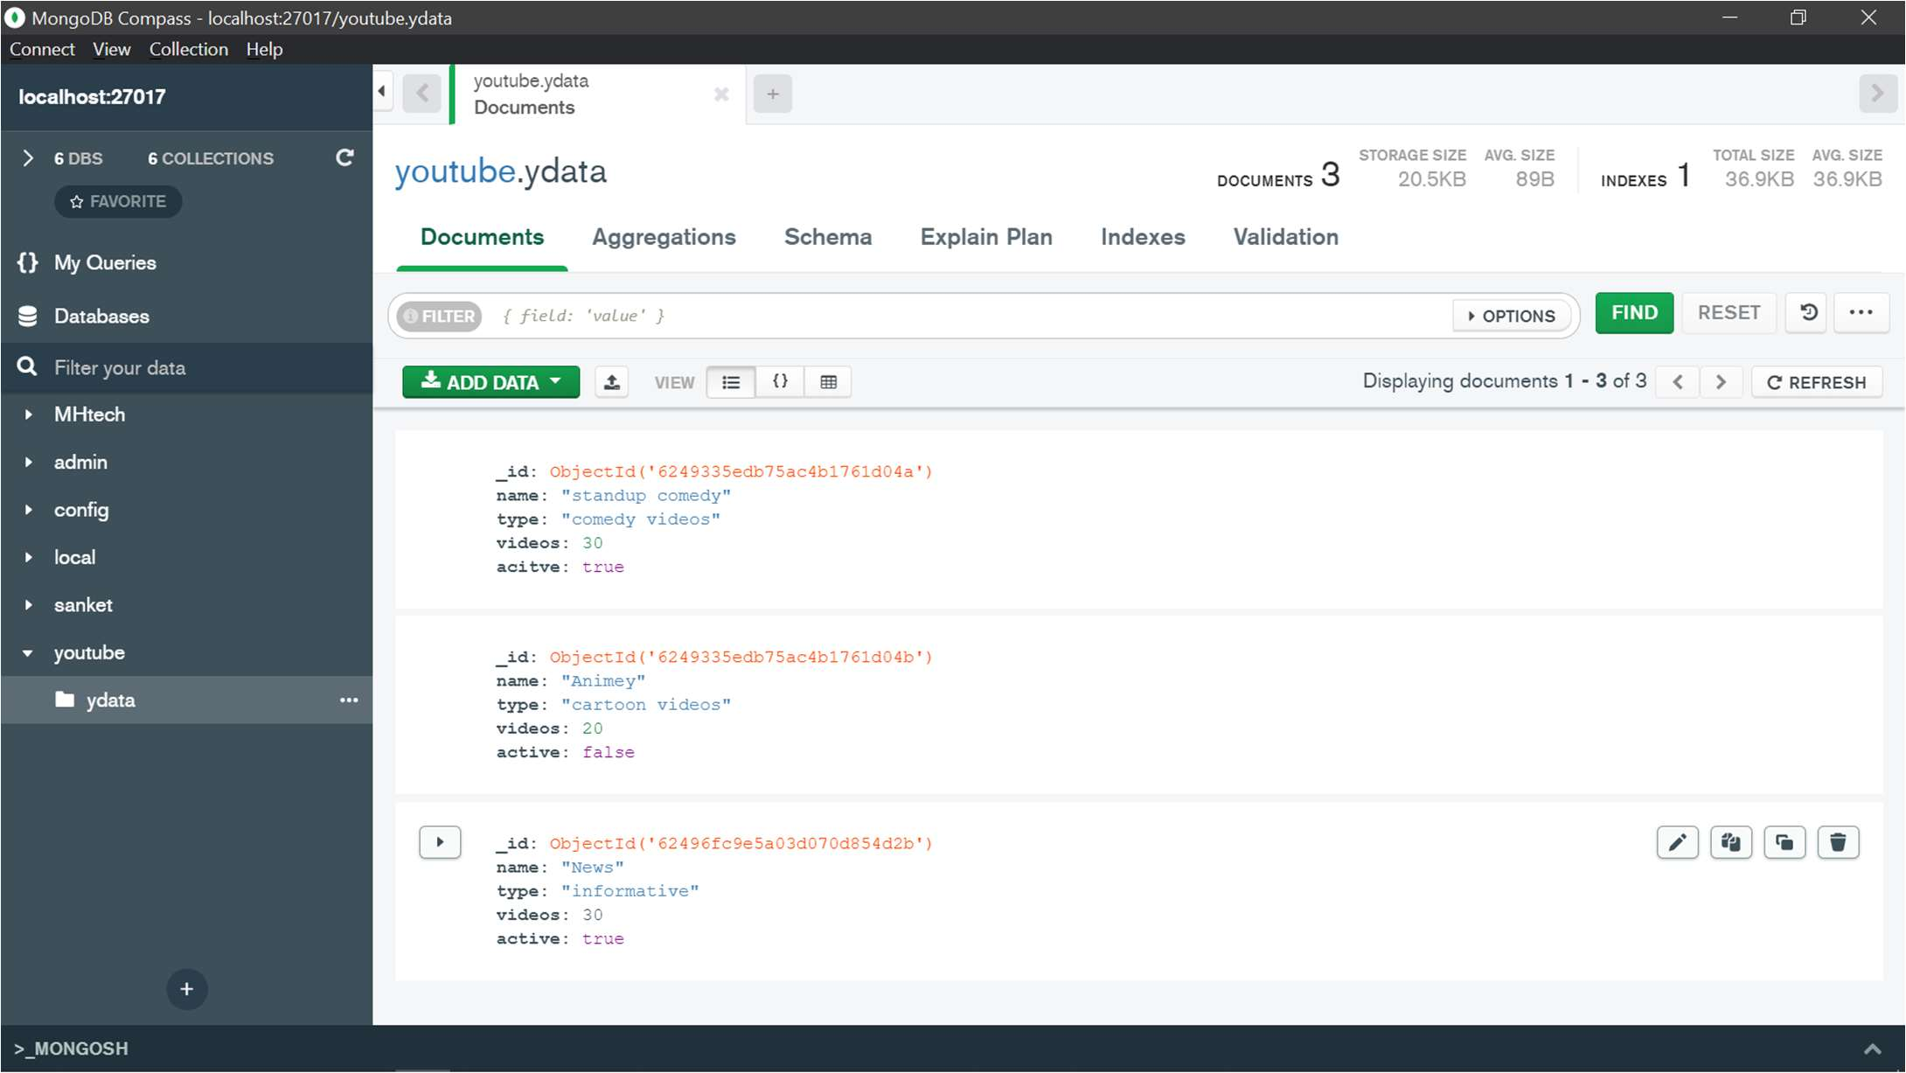

1. Read or filter query for document.
   1. On this page there is one filter bar where we can write our query to read documents.

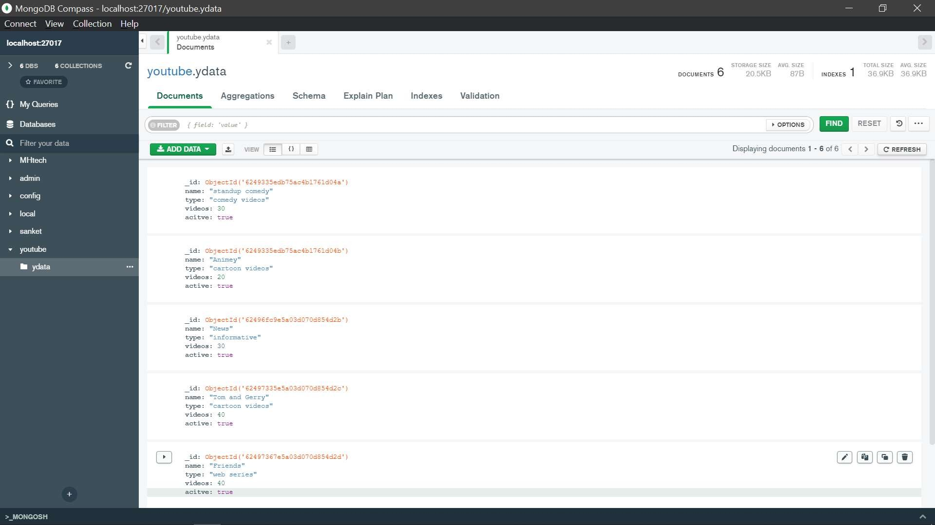

* 1. Now I am going to type one key-value pair(query) in this field and then it will show me the result.

Example: if I want to search for comedy videos from my collections then I simply type:-

{type: “comedy videos”} and enter

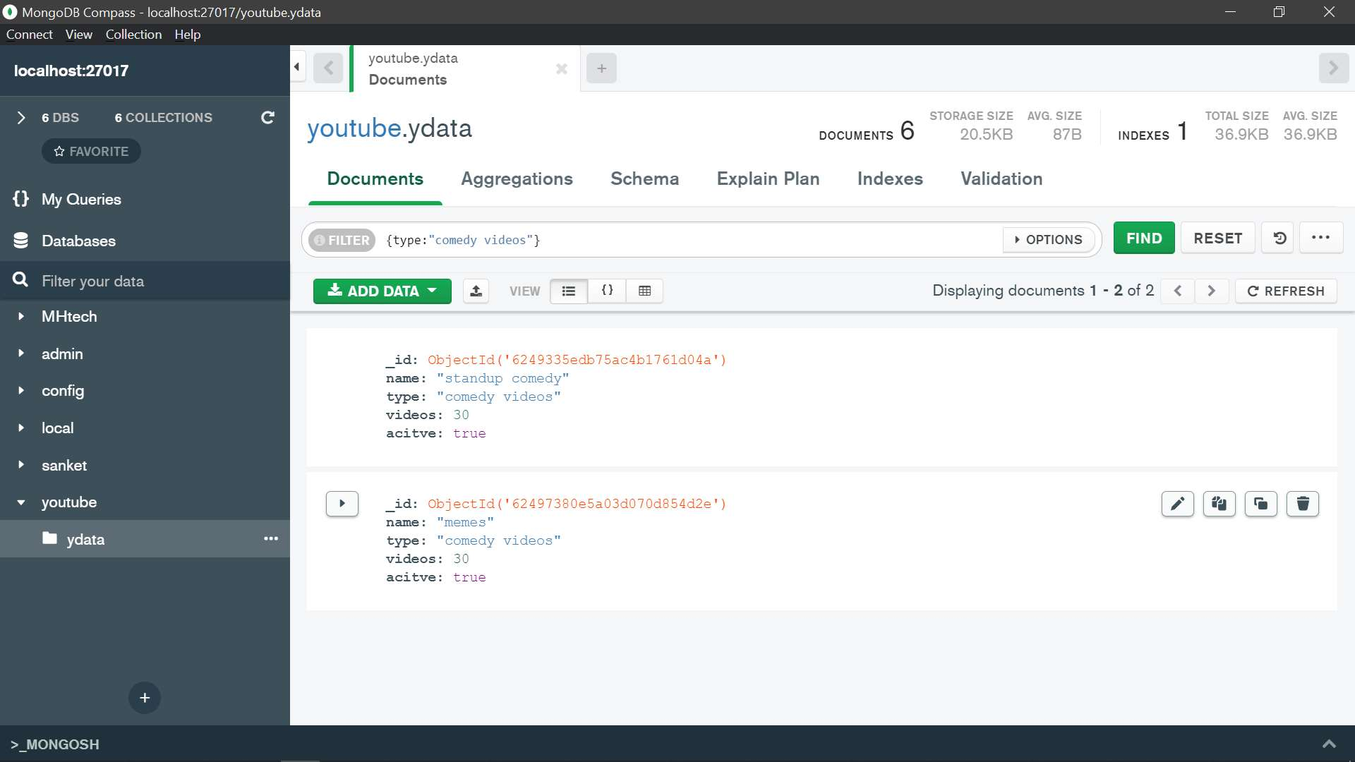

1. Update Documents in the collection.
   1. Now there is an edit option that is used to update the documents or data in collections.

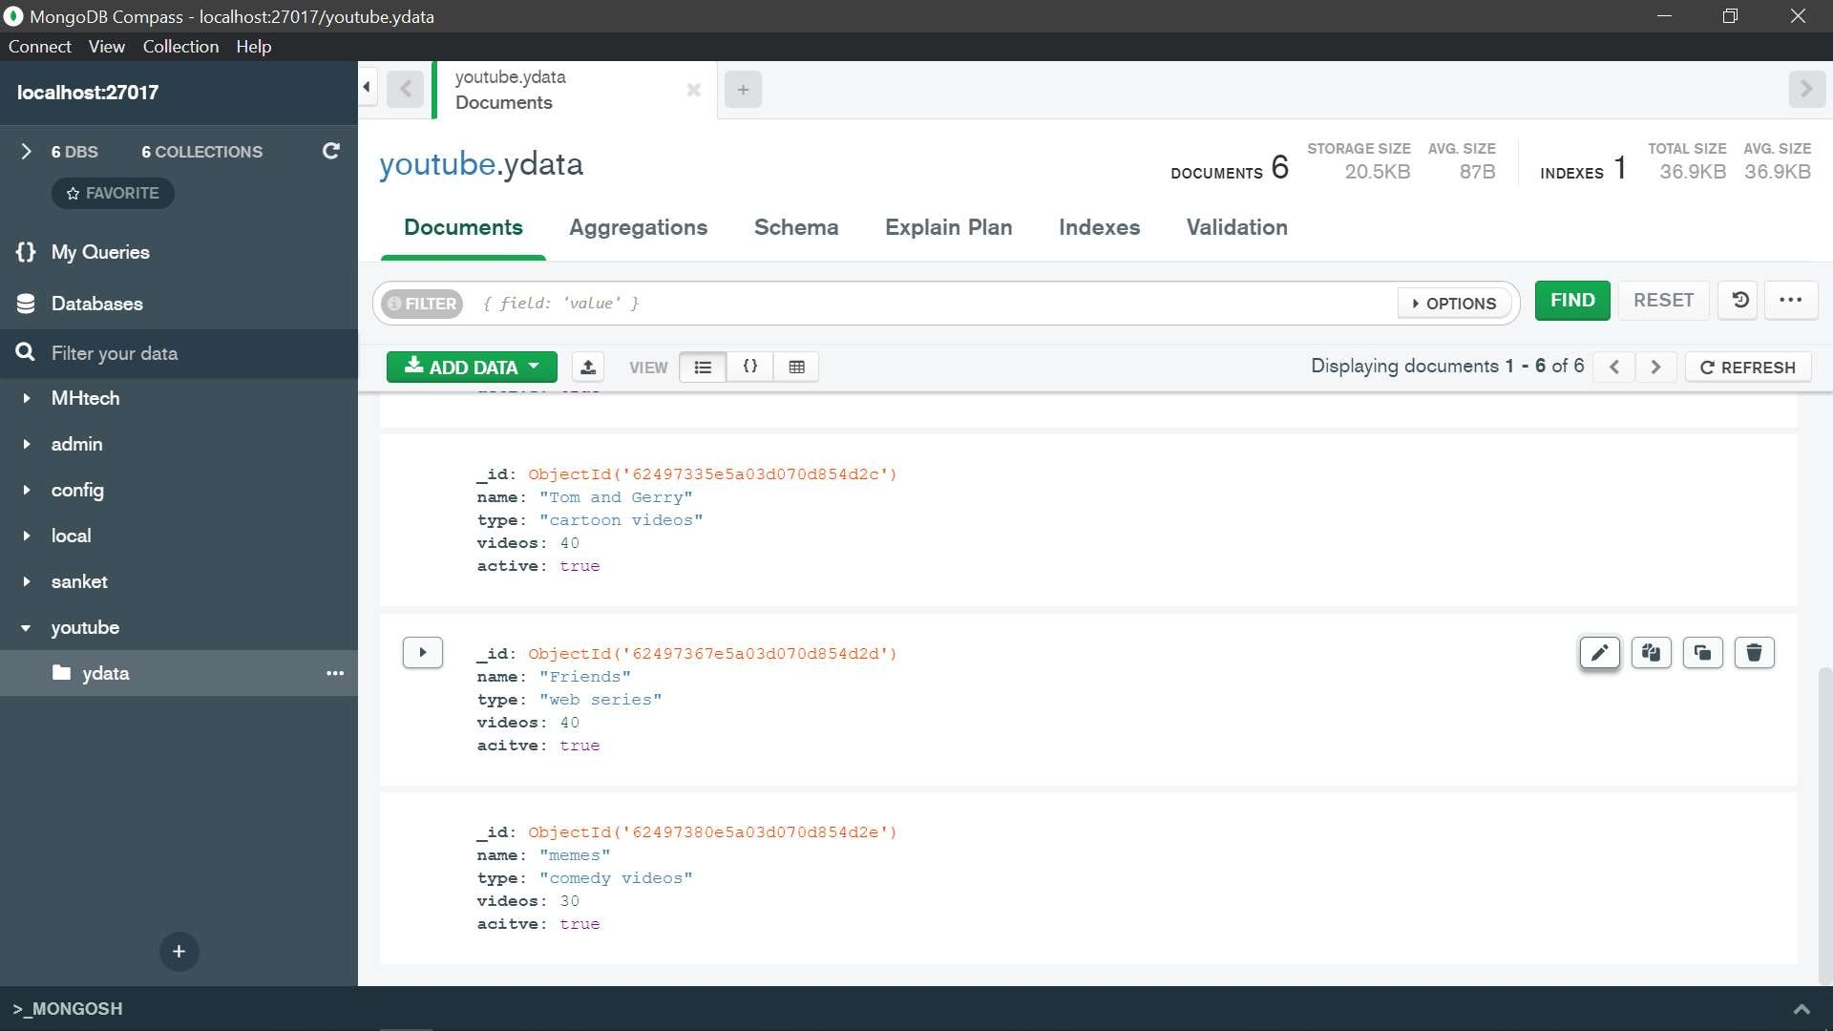

* 1. Suppose we have to update video numbers in friends document then we simply click on edit option and then put the value which we want.

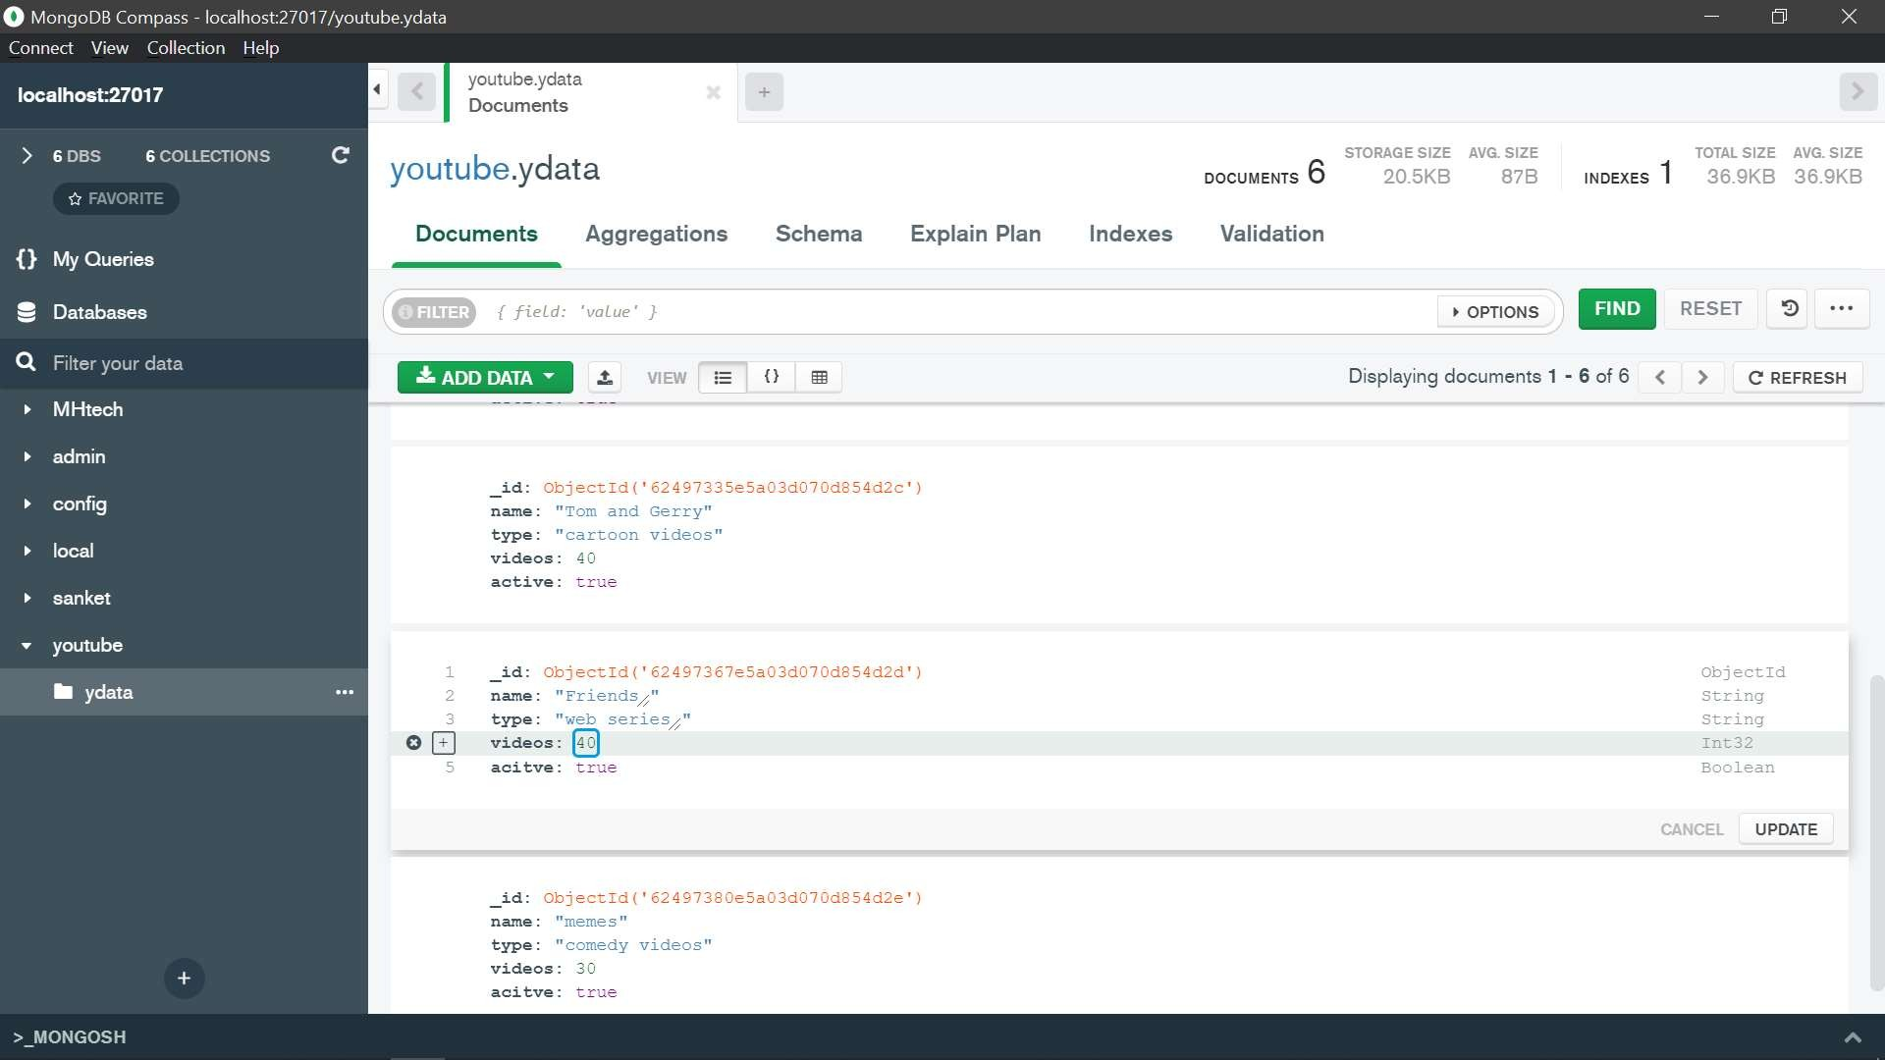

* 1. After updating the value we can click on the update button and then the document will be updated

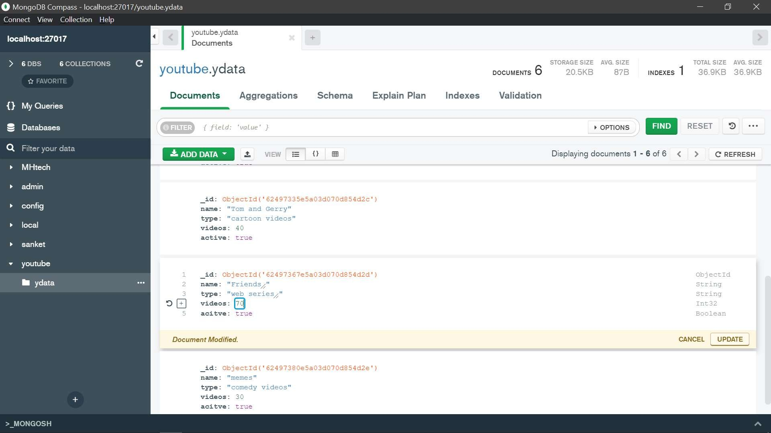

* 1. The following image is updated image.

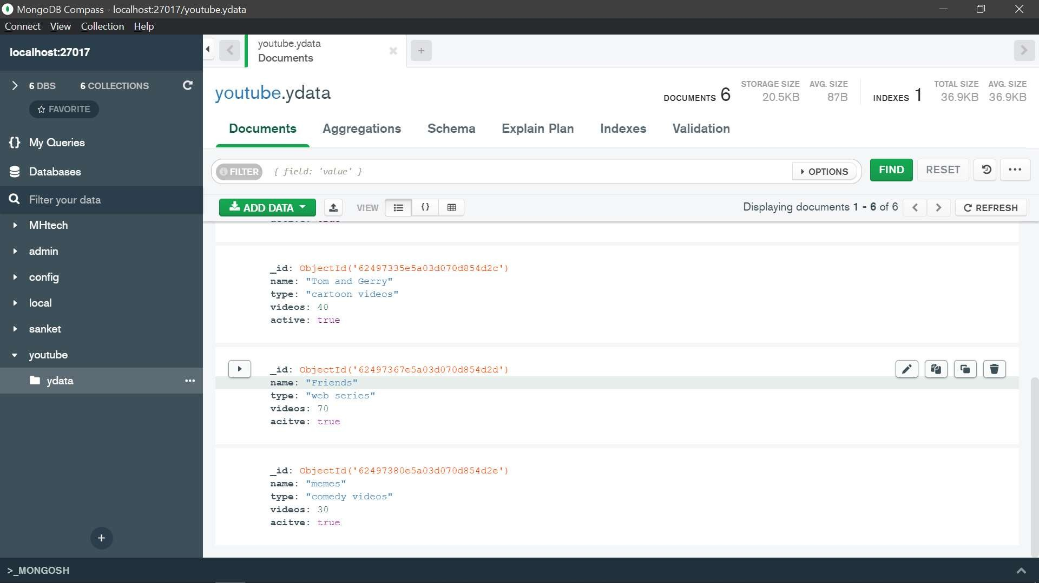

1. Delete documents or data in collections
   1. For deleting a particular document from collection there is one another button which is shown in picture.

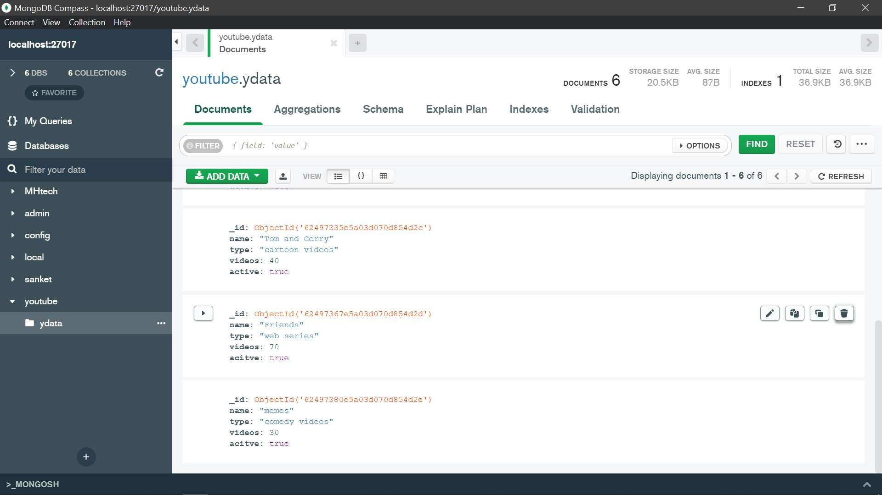

* 1. When we will press that button it will delete whole document.

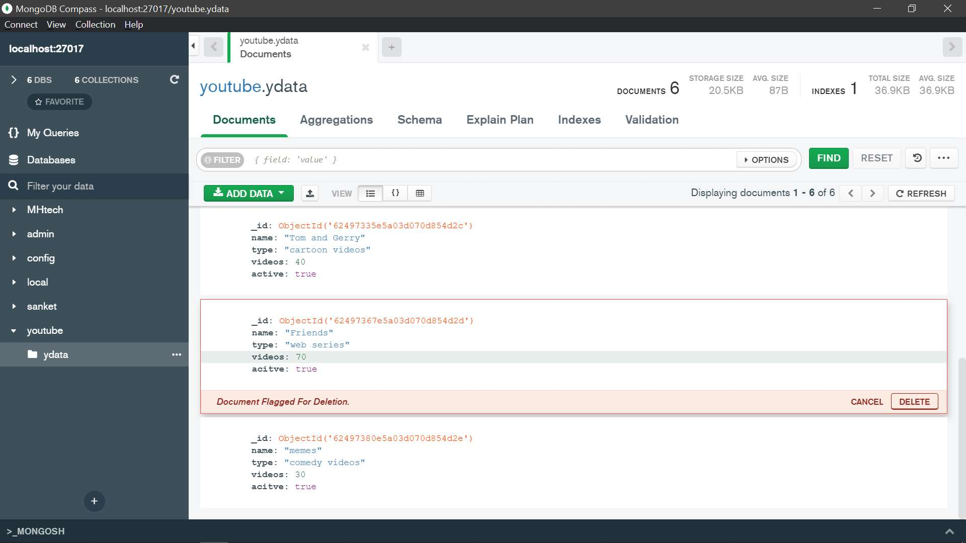

**Conclusion:-**we can use both Cmd and MongoDB compass for performing CRUD operations in MongoDB.But MongoDB compass is easy to use than cmd.

THANK YOU MAM